|  |
| --- |
| ENTER CURRENT LVL__1____ or XP______1____  [LOOK-UP USER, Insert OSRS HS link] Username:___Supa___  ACHIEVE LEVEL___2___ or XP ____83____  [CALCULATE]  Fastest Item to level: Crude Chair  Item--------------xp/perunit------xp/p/h--------gp/xp-----Needed  Crude Chair--------53--------------n/a-------stillalot------------2 |
|  |

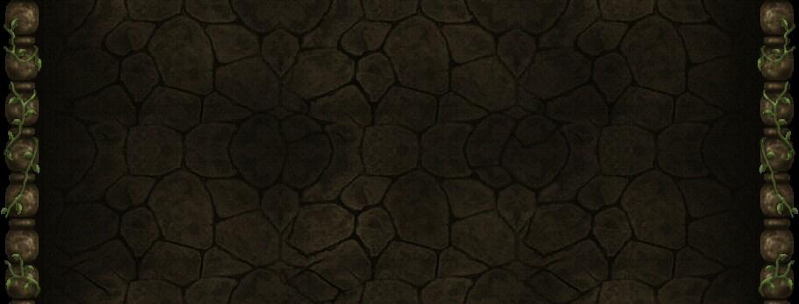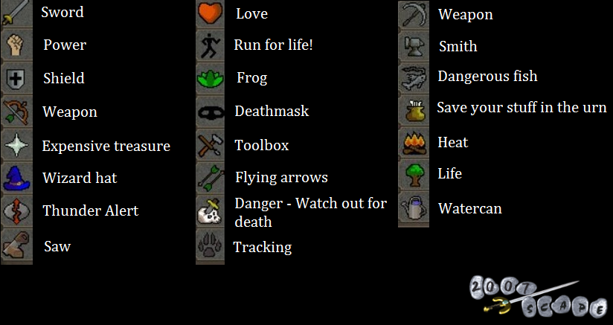kl

This is as rough as it gets. Basically have it osrs themes to keep the nostalgia factor in place. 2007rshelp has a blue interface which is kind of bland. Obvi the text wont be all yellow, but needs to be interactive to provide basic info to those who’d need it.

AS far as the skills go, just implement the picture icons to different tables/spreadsheets. Whenever you hover your mouse over a skill it should illuminate from all the rest.

Basic draft of how it would look, Add a home button to have a main directory. Welcome page if you will. Could be creative/funny to make attractive

(Make all the titles interactive bubbles that info shows when hovered and when clicked can stay.)

Intro/Tips:

Getting started- sdjkfhsdjkfhs get hammer do this get poh blah blah blah blah

Beginning- Levels 1-?? To start off, jasdjkfhajkshdshdkjfasdf

Avg. Cost-

Low end -1gabillz

Medium end- 1.5 gabillz

High End- 2.0 gabillz

Common XP Rates

Mahogany Tbles- 500kxp/ph

Oak Larders-120kxpp/h

Construction

Skills

**OSRS Skill Calcs**